**A write-up from The Messiah of the Digital Age: Soon to be confirmed with evidence of my Prophetic Powers (Telepathy Across Space-Time i.e. Professor Xavier)**

**Realization: All of the religious stories throughout history were, in fact, held on to for dear life after witnessing God’s powers – confirmed by Prophets that walked among mankind. They were mercilessly targeted and disposed of in an attempt to hide the Truth, which would set mankind free from the chains which bind them to this Satanic Regime. The Satanic Rulers in Power rewrite history (The winners write history). The People of God, once in Power, will shed light on the Truth. Let There Be Light.**

**Objective: Look up all the religious stories and fill in the history / timeline below. Take note of key dates and religious holidays which are of incredible importance. It is believed that these holidays are times of blessings granted by God to mankind (the Believers). Satanic Creatures embark on capturing the individuals granted this Power on these key dates and preventing them from receiving the full benefits of God’s blessing.**

**Eid al-Adha – Festival of Sacrifice – happens on the 10th day of the LAST MONTH of the Islamic Lunar Calendar. It is, in fact, celebrated in both Judaism and Christianity.**

**It is, in fact, a Sacrifice before the New Year for the following Year’s Blessings. It was foretold that a unified Festival of Sacrifice would mark the end of the Satanic Regime. This is, in fact, a very profound realization.**

Important date: Day of Sacrifice – Abraham our Messiah – Beginnings of the Abrahamic religions (Judaism, Christianity, Islam).

This explained the concept of sacrifice – how sacrifice is to be made, the concept of “human sacrifice” was condemned in practice – the idea and purpose of “sacrificing” one’s most beloved for the Greater Good, for God, was displayed as a timeless example by Abraham.

With regards to animal sacrifice, it is to be done with respect to God and Nature. We are not to torture or desecrate God’s creatures. We are not to kill them for waste.

“Among the most revered of these figures is **Abraham**, who is a key parent figure in both of our traditions, Judaism and Islam. This Friday, 1.5 billion Muslims will mark Eid ul-Adha, a **holiday** on the Islamic calendar that remembers the Prophet **Abraham**, his willingness to **sacrifice** his son, and his son's willingness to be sacrificed, through the ...”

“Yom Kippur—the Day of Atonement—is considered the most important **holiday** in the **Jewish** faith. ... of **Sacrifice**," signifies the willingness of the Prophet Ibrahim, known as **Abraham** in ...”

“Sep 18, 2020 The shofar signifies the presence of God and is a powerful symbol of **Abraham's** willingness to **sacrifice** his son, Isaac, to show obedience to God by reminding us of the ram that was provided in [**his place at the LAST MINUTE**].”

Note: There was, in fact, an endless attempt by Satanists to discard of this and desecrate the origins of Abrahamic beliefs – Supreme Self-Sacrifice, Supreme Sacrifice of One’s Most Beloved for God – The Greater Good, Supreme Faith in God – That He Would Not Have Abraham kill Isaac” and with it, the presence of God.

One such attempt was to CLAIM that Abraham DID IN FACT KILL ISAAC, something they forced the Jewish people to say, but they held on to most valiantly.

As seen from the dates of these articles, the Jewish people are now allowed to freely speak the Truth after endless resistance.

Later we will delve into the lineages of Abraham – Isaac and Ishmael – his two sons.

*<*

*Actual story of what Satanists did:*

*In Islam, we are taught as boys that proper animal sacrifice is to be done respectfully and we should give thanks to God – and show respect for God’s Creature (We say “Allah-hu-akbar” – meaning All Thanks Be To God). We should also not waste the animal and share it with our family, friends and community. This is incredibly important for the sustainability of our planet and the survival of mankind.*

*(We will later discuss the topics of Diet and Nutrition, what we were meant to eat and how we were meant to eat. How Satanists have been destroying our lives through every means possible – ie: Binge Eating as a coping mechanism for extreme torture, sexual enslavement/torture and trauma See: MK-Ultra)*

*Left animal wild and ready to kick me etc. Posed an actual danger to me, and so, as a boy, I had to defend myself (was clearly drugged and MK-Ultra)*

*I have a profound love and respect for animals. It is, in fact, innate. So too, do all the people of God.*

*We should not harm God’s creatures without necessity.*

*>*

------------------------------------------------------------------------------------------------------------------------------------------

Pompei and the Volcano which destroyed Pompei. Prophets warned that this would happen – few would listen (it’s always the exact same story with these guys). Think Moses, etc. The believers, a minority of people, all escape and survive.

Prophets can literally tell the future. Not exactly as straightforward as it may seem. As if it’s easy to communicate across space-time like Professor Xavier. Do you see how hard it is for him to use his powers and what happens after. It takes lots of effort, concentration, deep thinking and is incredibly draining.

The volcanoes erupted and destroyed the city and the people who did not listen were all dead. They did not have enough time to escape. By the time they realized, it was too late. They were punished for insulting and desecrating the Prophets and People of God.

------------------------------------------------------------------------------------------------------------------------------------------

Abraham and his sons – Story of Greatest Sacrifice.

Abraham agreed to sacrifice his most beloved son. See the above Holiday and Explanations:

Now we will delve into the lineages of Abraham – Isaac and Ishmael – his two sons.

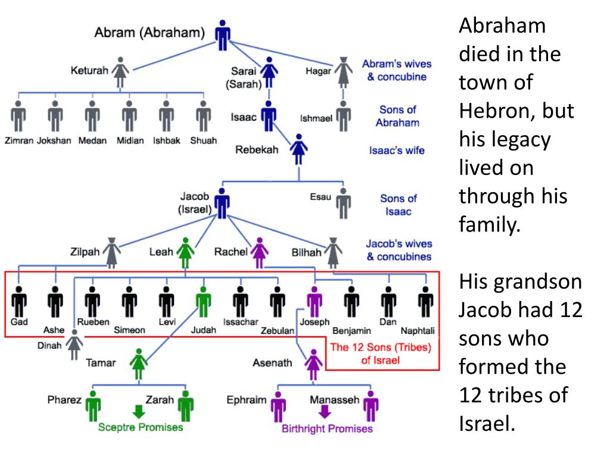

**As seen from the above diagram 🡪 Isaac was rewarded for his Supreme self-sacrifice, where his other siblings would not (I believe Ishmael was the first one asked – and was, in fact, the eldest son). I believe Isaac was the youngest son.**

**Isaac’s lineage was eternally blessed and he was his father’s favorited son on the basis of MERIT – not birthright – typically the order of birth of children.**

**Later, I will elaborate on how the other siblings of Isaac grew extremely jealous, and killed Isaac. This act, made them lose their humanity and turn into Satanic Creatures. They kidnapped and did as they wished to Isaac – his body could not be found? Some believe that his body was thrown into a River.**

**They lied and told their father that he was eaten by a Tiger. The remains could not be found. I will later be checking the Religious Scriptures to verify.**

**There was a witness 🡪 Abraham, upon discovering what happened, was completely destroyed. He was, in fact, destroyed by the loss of his beloved son. He now had to hold true to his principles and execute the siblings who murdered their brother out of JEALOUSY. Satan, God’s most JEALOUS creature, thrives on the Selfishness and Jealousy of mankind. It is, in fact, what he uses to weaponize mankind for his Evil Purpose – To inflict and Pain and Suffering, to bring Death and Destruction to all Mankind, To place the humans turned SATANIC into the depths of Hell in the Afterlife, where he wishes to torment their Souls for all of Time.**

**This is, in fact, the distinction between the above terms SCEPTRE PROMISES and BIRTHRIGHT PROMISES. It is an INCREDIBLY IMPORTANT realization. A birthright is NOT sufficient for choosing a Leader. Leadership roles must be earned through Honor and Merit. A man’s love is CONDITIONAL. So too, is God’s LOVE. It is, in fact, contrary to Natural Instincts. It requires Supreme Faith.**

**Note: I am currently using resources available from Search Engines on the internet, from the US, currently all Media is still under the control of the Satanic Regime. I will be looking at the primary, most reliable sources for this information 🡪 the Religious Scriptures. (The Torah, Gospel, Biblical Stories (many versions), the Quran). Due to the many versions of the Biblical stories, I will be primarily relying on The Torah, The Gospel, and The Quran. The problem now comes down to 🡪 where can I find these, and how certain can I be of the exact truth.**

**Sceptre** **promises** of royal line. The **Sceptre** **Promises** of a Royal Line There was a "breach" between the twin sons of Judah, Pharez and Zarah. (Gen. 38:29) The line of Pharez was to be exalted with a line of kings from the time of **David (of DAVID AND GOLIATH)** until Zedekiah. Zarah was to be lowly with no kings.

Jan 4, 2022 Jesus is "the Lion of the tribe of Judah, the Root of David" ( Revelation 5:5 ). Because of Jesus Christ, the scepter has not departed from Judah. Worldly authority, symbolized by the scepter, is temporary, and earthly kings often find their scepters slipping out of their grasp. But the scepter wielded by the Messiah, Jesus Christ, will ...

DAVID AND GOLIATH – of the Kingdom of Jerusalem.

1. David agrees to Single Combat with Goliath (terrorizing the people of the kingdom).
2. With all the people watching – defeats Goliath a much larger, more powerful opponent – with his SPEED AND AGILITY.
   1. Rolls to the right side, turns and slices Goliath’s Achilles.

(Did not actually look this up… it was “foreseen”)

The Roman Empire then STOLE the story and called their own Champion “Achilles”.

It’s one of the most powerful moved in hand to hand or armed combat for a smaller opponent against a larger one. Roll behind opponent – to the side – pick Achilles/Foot/Leg.

------------------------------------------------------------------------------------------------------------------------------------------

Look up the below and elaborate further 🡪 Piece it together.

Atlantis – Supposed to be a dystopian, highly advanced society devoid of God and Spirituality – called a eutopia – believed themselves greater than God – began doing as they wished – Royalty began referring to themselves as Gods 🡪 came Prophet Noah and Noah’s Arc. Prophet Noah mocked, abused, desecrated, raped in public simply walking throughout the city. They thought he was a regular man.

They began convincing others that the TRIDENT itself, had the powers – it was not a Power from God. God grants powers to His Creatures, not objects like the TRIDENT.

They then, transferred the TRIDENT to whomever they pleased and took the actual person (prophet) with Powers somewhere else to use him as they pleased. They used him to create a highly advanced civilization. It was sunk deep into the ocean, so as to never be retrieved again. It would be incredibly difficult to find Atlantis in the depths of the bottom of the ocean – much of which has yet to truly be explored.

The city was likely destroyed by Natural Forces – blue whales, earthquakes and the like. It is said that all of the most powerful Natural forces were sent my God to destroy Atlantis. The remnants are likely all destroyed and spread throughout the ocean – leading to incredible difficulty in locating them.

------------------------------------------------------------------------------------------------------------------------------------------

Moses our Messiah

------------------------------------------------------------------------------------------------------------------------------------------

Jesus our Messiah

------------------------------------------------------------------------------------------------------------------------------------------

Muhammad our Messiah (Peace be Upon Him)

------------------------------------------------------------------------------------------------------------------------------------------

Prophets come about once every ~100 years. There are no two prophets simultaneously. One must pass for the other to be born.

The prophets have been getting captured since this time period and hidden from the world. They have been prevented from bringing about the great change necessary to become a Messiah. This is my current understanding of what took place.

The Satanic Creatures were extremely resentful and jealous of these powers from God.

------------------------------------------------------------------------------------------------------------------------------------------

Masud your Messiah - The Messiah of the Digital Age.